# Charts.

Statistics is all about collecting, interpreting and representing data (the information which has been collected) in various forms. Some of the simplest ways of interpreting and representing data is in the form of graphs and charts. Please note every effort has been made to make this pack accessible but due to the nature of some of the content, the graphs and charts may not be accessible by some screen readers. If you have any queries or need any help, please email [learningdevelopment@northampton.ac.uk](mailto:learningdevelopment@northampton.ac.uk)

A bar chart uses bars drawn of equal width. The length of the bar is proportional to the amount or quantity it represents.

The simple example below can be used to illustrate the different ways that a bar chart can be drawn. In an exam you will sometimes be asked to draw a bar chart from a set of data. At other times you will be given a bar chart and be asked to obtain some information from it.

E.g. In a class, the colours of students' shirts were noted. 15 were red, 5 were green, 5 were blue, 3 were black and 2 were white. Put this data in bar chart form.

### 1. A Vertical Bar Chart.

The Vertical Bar Chart below shows the number of students wearing each shirt colour in one class.

Number of Students

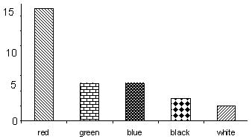



From the bar chart, we can see that there were 30 students in the class

(15 red + 5 green + 5 blue + 3 black + 2 white = 30 students)

The bars represent the data which was collected.

### 2. A Horizontal Bar Chart.

The Horizontal Bar Chart below shows the Shirt colours in one class:

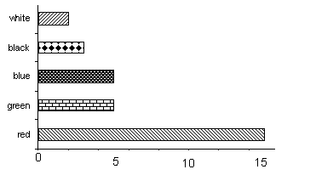 Number of Students

### 3. A Component Bar Chart.

Suppose that when we collected the information about shirt colours we had also distinguished between boys and girls.

The information table below shows the number of boys and girls wearing each shirt colour and their total.

Red shirts 3 (Boys) 12 (Girls) Total 15

Green shirts 2 (Boys) 3 (Girls) Total 5

Blue shirts 4 (Boys) 1 (Girl) Total 5

Black shirts 2 (Boys) 1 (Girl) Total 3

White shirts 0 (Boys) 2 (Girls) Total 2

Using this information, we could draw a component bar chart as shown below:

Number of Students

Girls

Boys

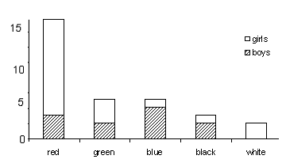

Shirt Colours

**Note:** The height of each column is equal to the total of the scores for boys and girls.

### 4. A Comparative Bar Chart.

Using the same data in 3 above, the Comparative Bar Chart below shows the Shirt colours in one class:

Number of Students

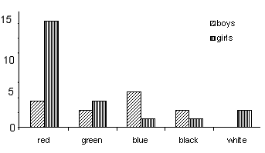

Shirt Colours

Girls

Boys

### 5. Line Graphs/ Line Charts.

These are variants on bar charts where the bars are replaced by lines. They may be vertical or horizontal and are most useful when two or more things are being compared. Using the same data in 3, the Line Chart below shows the Shirt colours in one class:

G = Girls

B = Boys

Number of Students

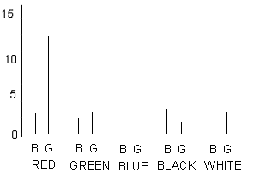

Shirt Colours

Remember that we can't use different coloured lines in the units. Students can and should do so in their own work. (For example, use a blue pen for boys and a red pen for girls.)

## Pie Charts.

We can work on the same data we have used in bar charts.

Shirt Colours in One Class:

15 Red

5 Green

5 Blue

3 Black

2 White

Total 30

The Pie Chart below shows the Colours in One Class.

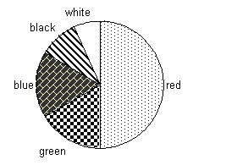

The size of each slice or sector depends on the angle at the centre of the circle, which in turn depends upon the number that the sector represents.

There are 360° at the centre of a circle and this represents 30 shirts,

thus $\frac{360}{30}=12°$ represents 1 shirt.

15 x 12° = 180° (red shirts)

5 x 12° = 60° (green shirts)

5 x 12° = 60° (blue shirts)

3 x 12° = 36° (black shirts)

2 x 12° = 24° (white shirts)

Total = 360°

Before you draw the chart check that the angles you have calculated total approximately 360°.

**To construct a pie chart:**

1. Draw a circle.

2. Mark the centre.

3. Draw any radius.

4. Place your protractor so that its centre is on the centre of the circle and the zero line coincides with the radius you have drawn.

5. Mark off the first sector angle and complete this sector.

6. Repeat 4 for each sector using the line you have just drawn as the base radius.

7. Label each sector clearly.

You may add colour if you wish but remember not to waste valuable time colouring in an exam.

## Pictograms.

Pictograms are sometimes called pictographs or ideographs.

**Example.**

The following data represents the Population of Great Britain excluding Ireland (figures in millions).

Year 1801

mm

mm

mm

mm

mm

m

Year 1851

mmmm

mmmm

mmmm

mmmm

mmmmm

Year 1901

mmmmmmmm

mmmmmmmm

mmmmmmmm

mmmmmmmm

mmmmm

10.5m

21.0m

37.0m

It is often difficult to gather accurate numerical information from a pictogram. In the above example although we know that m represents 1 million, it is more difficult to decide how many m stands for. For this reason, it is advisable to always include the relevant figures in the pictogram. The attraction of pictograms is that they can make a powerful visual impact and for this reason they are often used by newspapers and television. But **beware** pictograms can be misleading. Look at the next example.

This is the information that we wish to put across: - Milk sales in the UK were 12 million bottles in 1960 and 36 million bottles in 1980.

The Pictogram below shows one small milk bottle with a label of 1960 and a large milk bottle with a label of 1980.

**Milk Sales in the UK**



1980

1960

Looking at this pictogram alone we cannot be sure of our conclusions. If we compare the heights of the milk bottles, we would conclude that milk consumption has increased about three-fold. Whereas if we compared the areas that the pictograms take up on the page (which it is more natural for the eye to do), we would come to the conclusion that milk consumption had increased to more than three times what it was in 1960. There are two ways of avoiding this pitfall:

**Either**: include numerical information with the pictogram.

**OR** preferably, use a less ambiguous form of the pictogram, as shown in the example below.

**Milk Consumption in the UK**

**1960**



**1980**





= 4 million bottles

**Key:**



### Exercise 1.

3600 people who work in Bradford were asked about the means of transport which they use for daily commuting. The data collected is shown below.

Private Car 1800 (people)

Bus 900 (people)

Train 300 (people)

Other 600 (people)

Draw a) a vertical bar chart,

b) a pie chart.

### Exercise 2.

The figures below show the output of the Duffer Lorry Company in a certain year. Draw a suitable pictogram to represent the following information.

Production in thousands per month:

January: 300

February: 450

March: 700

April: 625

May: 500

### Answers.

**Exercise 1.**

a) The Vertical Bar chart below shows the type of transport used:

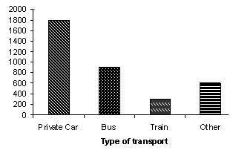

Private Car Bus Train Other

Type of transport

b) The Pie chart below shows the type of transport used:

Where the total number of people = 3600. 360° represents 3600.

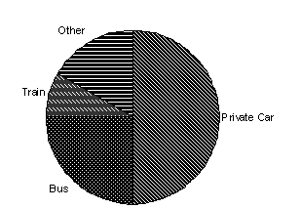

Other

Train

Private Car

Bus

**Exercise 2.**

Below is a pictogram representing the production in thousands for the Duffer Lorry Company.

**Key:** **= 25,000 lorries**

**Month: Production:**

January: 

February: 

March: 

April: 

May: 

This concludes the Statistics - Charts study pack.